1. Create a database named Clubs and create a table called “Cognizance” with columns Name, and Known_language.

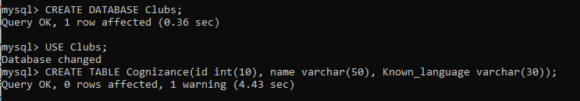

1. Inserting values to the table

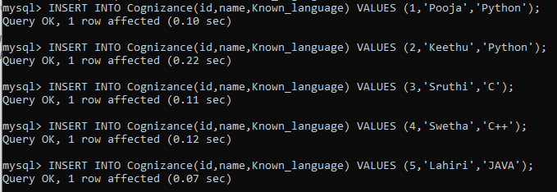

1. Displaying the names of all students who have “Python” as their *known_language*.

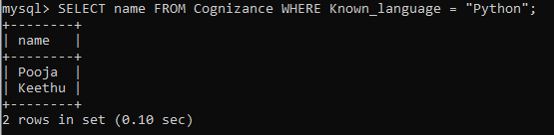

1. Updating the *known_language* of the first student that you have inserted into any other language and display the update by showing the whole table again.

